第六课时

学习目标：1．复习巩固1—10的数词。2．复习本单元所学句型及对话。
学习难点：对数词的熟练掌握和运用。操练 Let’s chant

同步练习
- 选出合适的云朵。
1. four one two
412
439

- three six nine
369
169

- seven five three
758
753

- eight one seven
871
817

二．单项选择
（ ）1.How many books?
————————
A．How are you? B. One. C. I’m five.

( )2.What’s this ?
____________.
A. It’s a cake. B . Good bye. C. I’m fine.
( )3.How old are you?
_________
- I’m Mike.
- I’m fine. Thank you.
- I’m nine years old.

三、看图拼单词
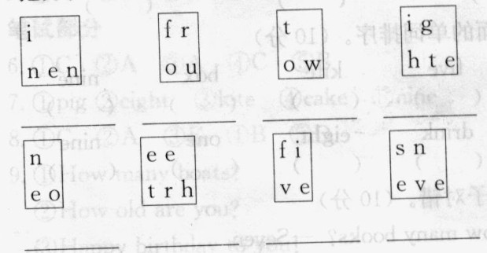
答案：一、略
二、1. B 2. A 3. C
三、nine four two eight one three five seven

